**`SRI KRISHNA COLLEGE OF THCHNOLOGY**

**An Autonomous Institution | Accredited by NAAC with 'A' Grade Affiliated to Anna University | Approved by AICTE**

**KOVAIPUDUR, COIMBATORE 641042**

**AQUACRUISE CLOUDBOOKER**

**A PROJECT REPORT**

#### Submitted by

**ASMITHA V 727821TUIT012**

**INBASRI M 727821TUIT038**

**KRITHIKA M 727821TUIT051**

in partial fulfillment for the award of the degree Of

**BACHELOR OF TECHNOLOGY IN**

**INFORMATION TECHNOLOGY**

**MARCH 2024**



# CERTIFICATE

II

# BONAFIDE CERTIFICATE

Certified that this project report **“AQUACRUISE CLOUDBOOKER –** **FULL STACK APPLICATION”** is the Bonafide work of **ASMITHA V, INBASRI V,KRITHIKA M** who carried out the project work under my supervision.

**SIGNATURE SIGNATURE**

#### Mrs.P.Dhivya Dr.S .SIAMALA DEVI

**SUPERVISOR HEAD OF THE DEPARTMENT**

Assistant professor, Assistant Professor,

Department of Department of

Information Technology, Information technology,

Sri Krishna College of Technology, Sri Krishna College of Technology, Coimbatore-641042 . Coimbatore-641042 .

Certified that the candidates were examined by us in the Project Work viva- voce examination held on at Sri Krishna College of Technology, Coimbatore -641 042.

**INTERNAL EXAMINER EXTERNAL EXAMINER**



# ACKNOWLEGDEMENT

**ACKNOWLEDGEMENT**

Dedicating this project to the **ALMIGHTY GOD** whose abundant grace and mercies enabled its successful completion.

We extend our deep gratitude to our beloved Principal, **Dr. M. G. Sumithra,** for her kindness and unwavering support throughout the project work.

We are grateful to our beloved Dean Academics affairs and assessment

**Dr. R. Rameshkumar,** for his tireless and relentless support.

We extend our heartfelt thanks to our beloved Dean Accreditation and Ranking **Dr.**

**P. Manju,** for her advice and ethics inculcated during the entire period of our study.

We would like to express our deep gratitude to **Dr. J. Shanthini,** Head of Computing Science and **Dr. S. Siamala Devi,** Head of Information Technology , for her exceptional dedication and care towards success of this project.

We would like to extend our heartfelt gratitude to our Project guide **Mrs.P.Dhivya,** Assistant Professor, Department of Information Technology for her valuable guidance and suggestion in all aspects that aided us to ameliorate our skills.

We are thankful to all those who have directly and indirectly extended their help us in completing this project work successfully.



# ABSTRACT

**ABSTRACT**

Cruise vacations offer unparalleled experiences of luxury and adventure, yet the process of booking them can often be cumbersome and time-consuming. To streamline this process and elevate the booking experience for travelers, we introduce Aqua Cruise Booker. This innovative platform harnesses the power of modern technology to simplify cruise bookings and provide travelers with a seamless journey from planning to embarkation.

Aqua Cruise Booker boasts an intuitive and visually appealing interface, guiding users through the booking process effortlessly. With comprehensive search and filtering options, travelers can refine their preferences based on destination, departure date, duration, and budget, ensuring that they find the perfect cruise tailored to their needs. Real-time updates on availability and pricing empower users to make informed decisions and secure their bookings with confidence.

Utilizing machine learning algorithms, Aqua Cruise Booker delivers personalized recommendations, helping travelers discover new destinations and experiences that align with their interests. Once users have selected their preferred itinerary, the platform facilitates a seamless booking process, complete with integrated payment gateways for secure transactions. Dedicated customer support and assistance are also available to address any queries or concerns, ensuring a hassle-free experience from start to finish.

In essence, Aqua Cruise Booker revolutionizes cruise bookings, offering convenience, efficiency, and personalized service at every stage. By leveraging cutting-edge technology and user-centric design, the platform aims to inspire travelers to embark on unforgettable voyages across the seas, creating memories that last a lifetime.

**TABLE OF CONTENT**



**TABLE OF CONTENT**

|  |  |  |
| --- | --- | --- |
| **CHAPTER NO** | **TITLE** | **PAGE NO** |
|  | **ABSTRACT** | **IV** |
|  | **LIST OF FIGURE** | **VI** |
|  | **LIST OF ABBREVIATION** | **VIII** |
| **1** | **INTRODUCTION** |  |
| 1.1 | PROBLEM STATEMENT | 1 |
| 1.2 | OVERVIEW | 1 |
| 1.3 | OBJECTIVE | 2 |
| **2** | **METHODOLOGIES** |  |
| 2.1 | HISTORY | 3 |
| 2.2 | PURPOSE | 3 |
| **3** | **SYSTEM SPECIFICATIONS** |  |
| 3.1 | SOFTWARE REQUIREMENTS | 4 |
|  | **TOOLS AND TECHNOLOGIES** |  |
| **4** | **USED** |  |
| 4.1 | HTML | 5 |
| 4.2 | CSS | 6 |
| 4.3 | JAVASCRIPT | 7 |
| **5** | **IMPLEMENTATION** |  |
| 5.1 | UML DIAGRAM | 8 |
| 5.2 | FRONT- END | 13 |
| **6** | **CONCLUSION** | **46** |
| 6.1 | FUTURE SCOPE |  |
| **7** | **REFERENCES** | **47** |

**LIST OF FIGURES**



**LIST OF FIGURES**

|  |  |  |
| --- | --- | --- |
| **CHAPTER NO** | **TITLE** | **PAGE NO** |
| 3.1 | VISUAL STUDIO | 4 |
| 4.1 | HTML | 6 |
| 4.2 | CSS | 6 |
| 4.3 | JAVASCRIPT | 7 |
| 5.1 | USE CASE DIAGRAM | 8 |
| 5.2 | CLASS DIAGRAM | 9 |
| 5.3 | SEQUENCE DIAGRAM | 10 |
| 5.4 | ACTIVITY DIAGRAM | 11 |
| 5.5 | ER DIAGRAM | 12 |
| 5.6 | ENHANCED ER DIAGRAM | 13 |
| 5.7 | FRONT END | 14 |
| 5.8 | HOME PAGE | 14 |
| 5.9 | LOGIN PAGE FLOWCHART | 16 |
| 5.10 | LOGIN PAGE | 17 |
| 5.11 | REGISTER PAGE FLOWCHART | 20 |
| 5.12 | REGISTER PAGE | 20 |
| 5.13 | BOOKING PAGE | 22 |
| 5.14 | ROOMS PAGE | 25 |
| 5.15 | ADMIN DASHBOARD | 27 |
| 5.16 | ADMIN USER | 30 |
| 5.17 | ADMIN EDIT PAGE | 32 |

**LIST OF ABBREVATIONS**



**LIST OF ABBREVATIONS**

|  |  |
| --- | --- |
| **ABBREVATIONS** | **ACRONYMS** |
| HTML | **HYPERTEXT MARKUP LANGUAGE** |
| CSS | **CASCADING STYLE SHEET** |
| JS | **JAVASCRIPT** |
| DOM | **DOCUMENT OBJECT MODEL** |

**INTRODUCTION**



1

# CHAPTER 1 INTRODUCTION

The chapter introduces the AquaCruise CloudBooker, that aims to streamline the booking process, enhance accessibility to diverse cruise options, and catalyze the growth of the waterway travel industry. Aqua Cruise Booker is a pioneering platform designed to transform the way travelers plan and book cruise vacations. Built upon the principles of convenience, efficiency, and personalized service, this innovative system offers a seamless booking experience from start to finish.

# PROBLEM STATEMENT

The current process of booking waterway cruises is fragmented and cumbersome, presenting challenges for both travelers and cruise operators. Travelers often face a daunting task when trying to find suitable cruises, as they must navigate through multiple websites or contact various operators. This not only consumes a significant amount of time but also leads to a frustrating experience, as the information available can be inconsistent and incomplete.

On the other hand, cruise operators find it challenging to reach their target audience efficiently and manage bookings effectively. Without a centralized platform, operators must rely on traditional marketing methods and struggle to compete with larger cruise lines. This results in missed opportunities to attract customers and maximize bookings, ultimately impacting their bottom line.

# OVERVIEW

AquaCruise Booker is a pioneering platform designed to transform the way travelers plan and book cruise vacations. Built upon the principles of convenience, efficiency, and personalized service, this innovative system offers a seamless booking experience from start to finish.

At the heart of AquaCruise Booker is its user-friendly interface, which provides travelers with easy access to a wealth of information and features. From browsing destinations and cruise lines to customizing itineraries and exploring onboard amenities, users can navigate the platform effortlessly, thanks to its intuitive design.

One of the key features of AquaCruise Booker is its comprehensive search and filtering capabilities. Travelers can refine their search based on various criteria such as destination, departure date, duration, and budget, enabling them to find the perfect cruise that matches their preferences.

2

# OBJECTIVE

AquaCruise Booker aims to revolutionize the waterway travel industry through the development of a comprehensive web application. The objective is to create a centralized platform that seamlessly connects travelers with a diverse array of waterway cruises worldwide, while empowering cruise operators to efficiently manage bookings and reach their target audience. By streamlining the booking process, enhancing user experience, empowering cruise operators, and promoting industry growth, AquaCruise Booker endeavors to redefine the landscape of waterway travel, making it more accessible, enjoyable, and sustainable for travelers and operators alike.

Upcoming chapter defines the methodologies involved, history and the purpose of Water consumption Tracker application.

**METHODOLOGIES**



**METHODOLOGIES**

* 1. **HISTORY**

The inception of Aqua Cruise Booker arose from a thorough examination of the cruise vacation industry, which highlighted the complexities and inefficiencies inherent in the booking process. Recognizing the opportunity to address these challenges and enhance the overall booking experience for travelers, a team of visionaries embarked on the journey to develop a revolutionary solution.

Extensive research and development efforts marked the initial phase of Aqua Cruise Booker's evolution. This phase involved in-depth market analysis, user behavior studies, and exploration of technological advancements. By understanding the needs and preferences of travelers and identifying the gaps in the market, the groundwork was laid for the creation of a cutting-edge booking platform.

## PURPOSE

The purpose of a water consumption tracker is to promote optimal health and well-being by increasing awareness about the importance of proper hydration. It empowers individuals to monitor and manage their daily water intake, set personalized hydration goals, and receive timely reminders for consistent hydration.

The upcoming chapter defines the environmental setup of the application.

# ENVIRONMENTAL SETUP



**3.1 INSTALLATION OF VISUAL STUDIO CODE**

A software package known as an integrated development environment, or IDE, integrates the essential tools required to design and test software. Developers use a range of tools for writing, creating, and testing software code. Examples of development tools include text editors, code libraries, compilers, and test environments. Developers can give commands immediately on VSC without needing to open a terminal process thanks to a built-in terminal system on VSC, which makes it easier to check for errors. The fact that VSC comes with a built-in GIT command that enables diff checking, staging files, and committing directly from the editor is another reason to choose it.

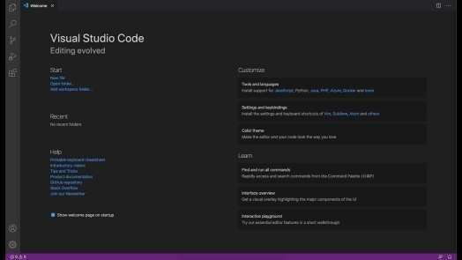

**Fig 3.1 Visual Studio**

The upcoming chapter discusses the tools and technologies used such as HTML, CSS, JAVASCRIPRT.

**TOOLS AND TECHNOLOGIES USED**

Multiple technologies and applications were employed in the "buy casa" project.

* 1. HTML
  2. CSS
  3. JavaScript

## HTML

Hypertext Markup Language is referred to as HTML. To create web pages, this language is utilized. The creation of interactive and responsive pages on the pages is also supported by this language, along with other languages like CSS, PHP, JAVASCRIPT, etc. Simply put, HTML5 is HTML in a more modern form. It enables brand-new functions, characteristics, HTML components, video and audio, as well as 2D and 3D images, all of which are helpful to users and web designers in their ability to easily add brand-new functions to websites. Figure illustrates the structure of HTML5.

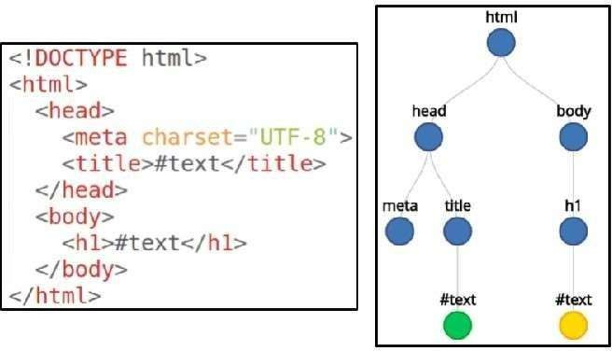

**Fig 4.1 HTML**

## CSS – CASCADING STYLE SHEET

Cascading Style Sheets is the short name for CSS. CSS is used to specify the design, layout, and display variants for web pages on various devices and screen sizes. The basic organization of CSS is as

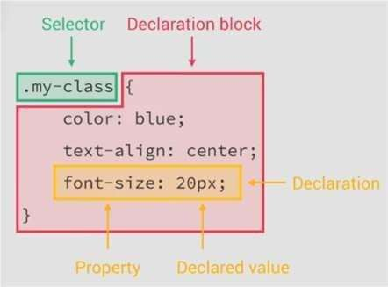

**Fig 4.2 CSS**

**7**

## JAVASCRIPT

A JavaScript-based UI development library is called React. It is managed by Facebook and an open source development community. The library made its debut in May 2013 and is currently one of the frontend libraries for web development that is most frequently used. Our React project folders are as follows:

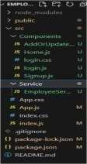

**Fig 4.3 Javascript**

The upcoming chapter will explain the UML diagrams involved such as usecase activity, sequence, ER, ERR diagrams.

# IMPLEMENTATION

8

# CHAPTER 5

**IMPLEMENTATION**

In this chapter the detailed explanation of the project will be seen. How the front-end i.e., the UI works.

# FRONT-END

A front-end developer is a type of software developer who specializes in creating and designing the user interface (UI) and user experience (UX) of websites and web applications. The primary responsibility of a front-end developer is to ensure that the visual and interactive aspects of a website or application are user- friendly, aesthetically pleasing, and functionally efficient.

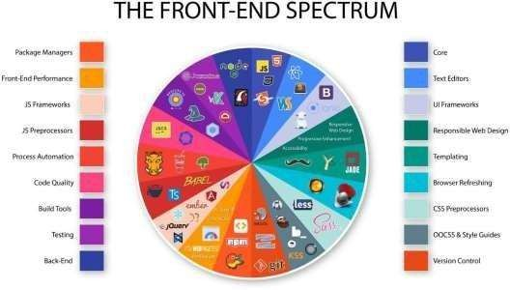

**Fig 5.7 Front-End**

# HOME PAGE

A Home page is a page where the projects first and foremost page begins where it contains the project description and it contains top bar, side bar which displays activities, contact us, logout.

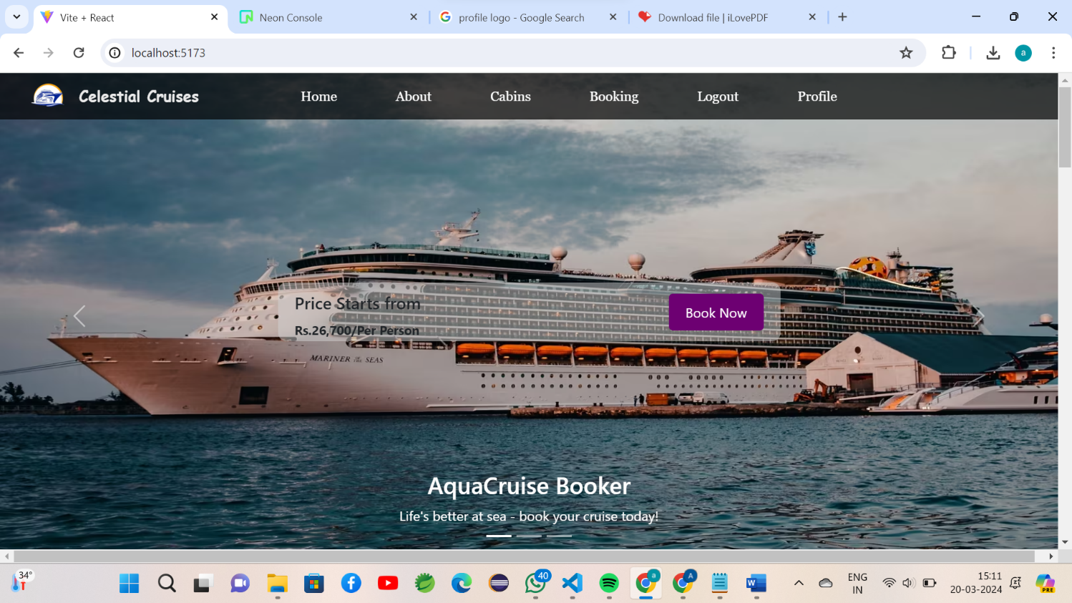

**Fig 5.8 Home page**

#### 15

#### Js code :

import React from 'react';

import { Container, Row, Col, Image, Card, Button } from 'react-bootstrap';

import "../assets/css/Home.css";

import { Link } from 'react-router-dom';

import Carousel from 'react-bootstrap/Carousel';

import cruise from '../assets/images/cruise.avif';

import cruise2 from '../assets/images/cruise2.jpg';

import cruise3 from '../assets/images/cruise3.jpg';

import live from "../assets/images/live.jpg";

import wine from "../assets/images/wine.jpg";

import Nav from './Nav';

import Footer from './Footer';

const cardStyle = {

width: '350px',

height:'400px',

top:"700px",

left:"70px"

};

const boxStyle = {

backgroundColor: '#f2f2f2',

padding: '5px',

width:'350px',

marginLeft:'-17px',

textAlign: 'center',

};

function CustomCard({ title, date, price }) {

return (

<Card style={cardStyle}>

<Card.Img variant="top" src={place} />

<Card.Body>

<Card.Title style={{ textAlign:'center' }}>{title}</Card.Title>

<div style={boxStyle}>

<Card.Text>{date}</Card.Text>

</div>

);

}

export default function UncontrolledExample() {

return (

<div className="home-wrapper">

<Nav/>

<Carousel interval={1500}>

<Carousel.Item>

<img className="carousel-img" src={cruise} height="580px" width="1400" alt="First slide" />

<Carousel.Caption>

<h3>AquaCruise Booker</h3>

<p1>Life's better at sea - book your cruise today!</p1>

</Carousel.Caption>

</Carousel.Item>

<Carousel.Item>

<div className='homerec'>

<div>

<h4>Price Starts from</h4>

<p4>Rs.26,700/Per Person</p4>

</div>

<button className="bookNowButton1"><Link to="/booking">Book Now</Link></button>

</div>

<div className='content1'>

<h5>Unlimited Entertainments</h5>

<p>Set Sail for Unlimited Entertainment: Dive into a World of Endless Fun on Our Cruise Ship</p>

</div>

<Col style={{ marginLeft: '-10px' }}>

<CustomCard

title="Cochin-Lakshadweep-Cochin"

date="Apr 10, 2024 to Apr 18, 2024"

price="Rs.40,358"

/>

</Col>

</Row>

<Footer/>

</div>

);

}

# LOGIN PAGE

A login is a set of credentials used to authenticate a user. Most often, these consist of a username and password. However, a login may include other information, such as a PIN number, passcode, or passphrase. Some logins require a biometric identifier, such as a fingerprint or retina scan.

Logins are used by websites, computer applications, and mobile apps. They are a security measure designed to prevent unauthorized access to confidential data. When a login fails (i.e, the username and password combination does not match a user account), the user is disallowed access. Many systems block users from even trying to log in after multiple failed login attempts.

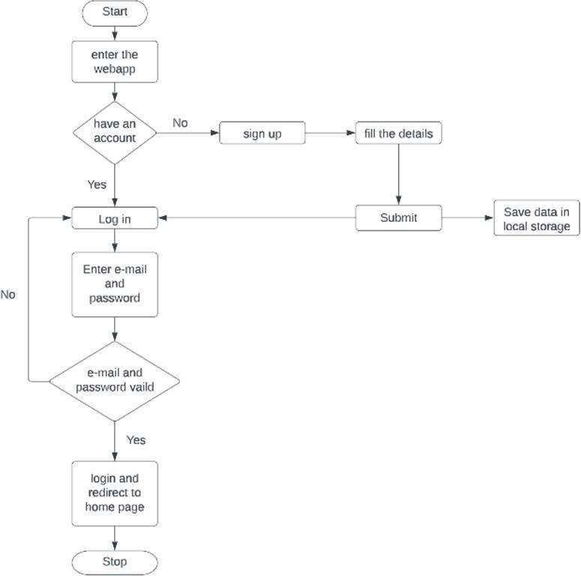

**Fig 5.9 Login Page Flowchart**

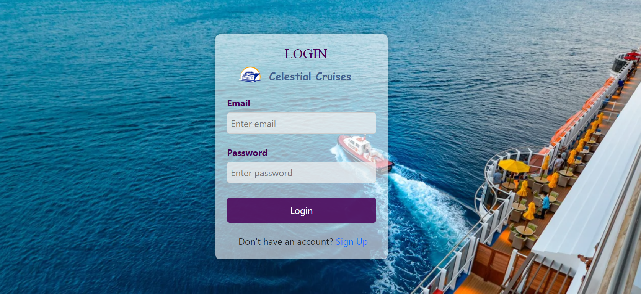

### Fig 5.10 Login Page

### Js Code :

import React, { useState } from 'react';

import "../assets/css/Login.css";

import { Link, useNavigate } from 'react-router-dom';

import logo2 from "../assets/images/logo2.png";

export default function Login() {

const [email, setEmail] = useState('');

const [password, setPassword] = useState('');

const navigate = useNavigate();

const formHolder = (e) => {

e.preventDefault();

const regex = /^[^\s+@]+@[^\s@]+\.[^\s@]{2,}$/i;

if (email.length === 0 || password.length === 0) {

alert("Enter all the fields");

}

else if (email === "admin@gmail.com" && password === "admin") {

navigate('/admin');

} else if (password.length < 8) {

alert("Enter at least 8 characters in password");

} else {

navigate('/');

}

};

return (

<div className="login-container">

<form className="login-form" onSubmit={formHolder}>

<img className="logoo" src={logo2} alt="logo" width="50px" height="50px"/>

<h2>LOGIN</h2>

<p>Celestial Cruises</p>

<div className="form-groupl">

<label>Email</label>

<input type="email" placeholder="Enter email" value={email} onChange={(e) => setEmail(e.target.value)} required/>

</div>

<div className="form-groupl">

<label>Password</label>

<input type="password" placeholder="Enter password" value={password} onChange={(e) => setPassword(e.target.value)} required/>

</div>

<div className='logbut'>

<button type="submit" id='sibtn'>Login</button>

</div>

<div className="lsignup">

<p1>Don't have an account? <Link to='/register'>Sign Up</Link></p1>

</div>

</form>

</div>

);

};

# REGISTER PAGE

A register page enables users and organizations to independently register and gain access to your system. It is common to have multiple signup pages depending on the types of people and organizations you want to register. In this article you will learn about the different types of signup pages, how to configure them and related functionality. Global Administrator access is required to create and modify signup pages.

20

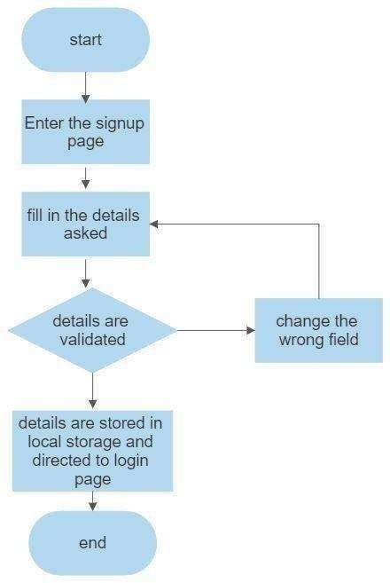

**Fig 5.11 Register Page Flowchart**

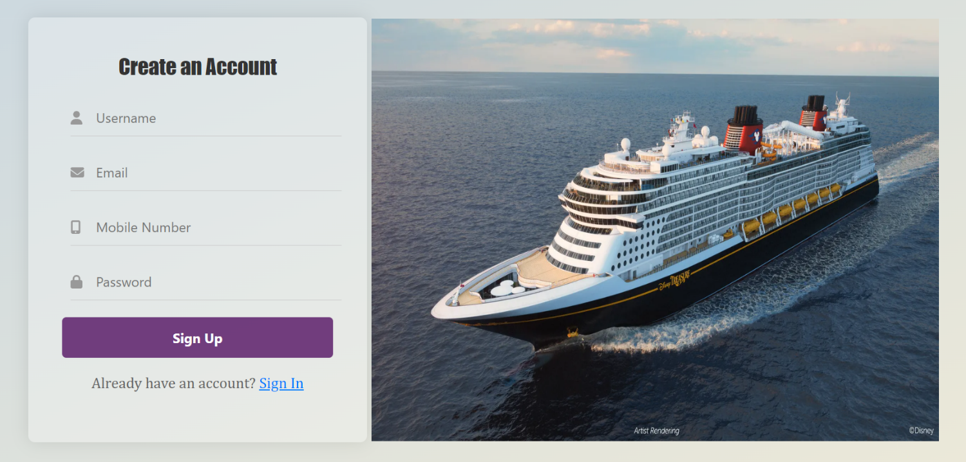

**Fig 5.12 Register Page**

#### 21

#### Js code:

import React, { useState } from 'react';

import { FontAwesomeIcon } from '@fortawesome/react-fontawesome';

import { faUser, faEnvelope, faMobileAlt, faLock } from '@fortawesome/free-solid-svg-icons';

import "../assets/css/Register.css";

import { useNavigate } from 'react-router-dom';

import regg from "../assets/images/regnew.webp";

import logo2 from '../assets/images/logo2.png';

import { Link } from 'react-router-dom';

export default function Register() {

const navigate=useNavigate();

const [username, setUsername] = useState('');

const [email, setEmail] = useState('');

const [mobile, setMobile] = useState('');

const[password,setPassword]=useState('');

const handleRegister = (e) => {

e.preventDefault();

const regex = /^[^\s+@]+@[^\s@]+\.[^\s@]{2,}$/i;

if(username.length===0 || email.length===0 || mobile.length===0 || password.length===0)

{

alert("Enter all the fields");

}

if(!regex.test(email))

{

alert("Enter a valid Email Address");

}

if(password.length<8)

{

alert("Enter atleast 8 characters in password");

}

if(mobile.length<10)

{

alert("Enter atleast 10 characters in mobile number");

}

else{

navigate('/');

}

}

return (

<div className="register-container" >

{/* <img className="aqualogo" src={logo2} width="40px" height="40px"/>

<div className="name">

<p>Celestial Cruises</p>

</div> */}

<div className="register-form-container">

<form className="register-form" onSubmit={handleRegister}>

<h2>Create an Account</h2>

<div className="form-groupr">

<input type="text" placeholder="Username" value={username} onChange={(e) => setUsername(e.target.value)} required/>

<FontAwesomeIcon icon={faUser} className="icon" />

</div>

<div className='regbut'>

<button type="submit">Sign Up</button>

</div>

<div className="login">

<p>Already have an account? <Link to='/login'>Sign In</Link></p>

</div>

</form>

</div>

<div className="reg-image">

<img src={regg}/>

</div>

</div>

)

}

# BOOKING PAGE

This page allows users to book cruises based on preferred date and can also choose cabin.

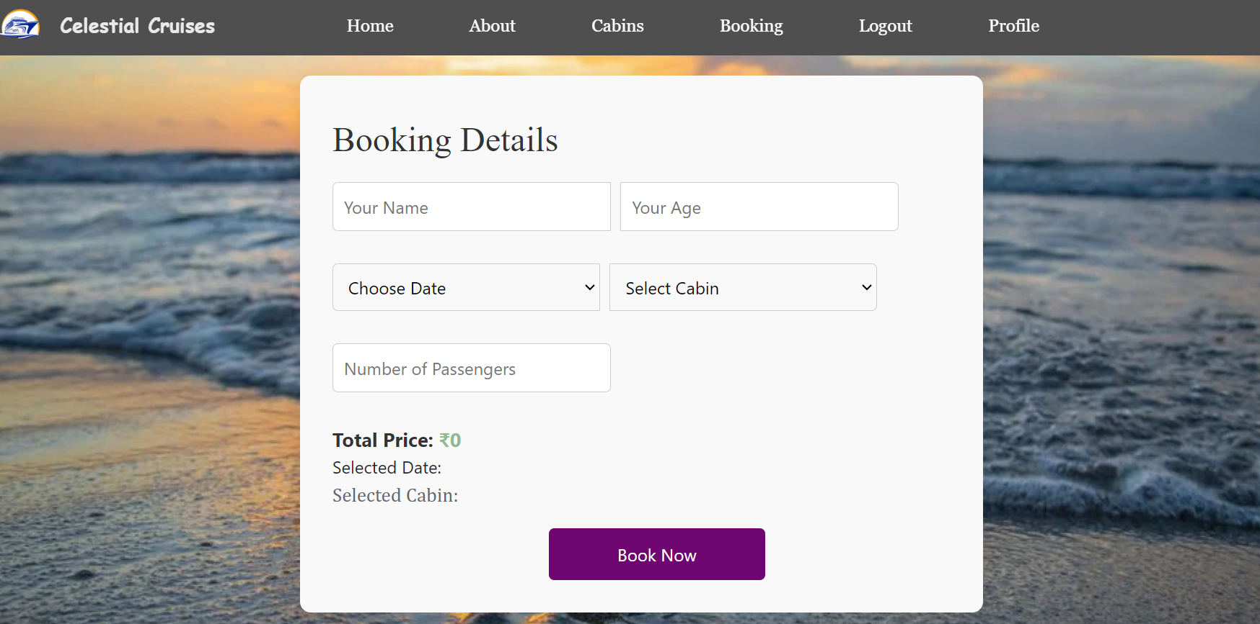

**Fig 5.13 Booking Page**

23

### Js code :

import React, { useState, useEffect } from 'react';

import axios from 'axios';

import Nave from './Nave';

function TodayPage() {

const [container, setContainer] = useState('Cup');

const token = localStorage.getItem('token');

const username = localStorage.getItem('username');

const [lastDailyTotal, setLastDailyTotal] = useState(null);

useEffect(() => {

axios

.get(http://localhost:8080/auth/history/${username})

.then((response) => {

if (response.data.length > 0) {

setLastDailyTotal(response.data[response.data.length - 1].dailyTotal);

}

})

.catch((error) => {

console.error('Error fetching last dailyTotal:', error);

});

}, [username])

const handleLogIntake = (selectedContainer) => {

let iconAmount = 0;

if (selectedContainer === 'Cup') {

iconAmount = 250;

} else if (selectedContainer === 'Glass') {

iconAmount = 500;

} else if (selectedContainer === 'Bottle') {

iconAmount = 750;

}

const newTotal = lastDailyTotal !== null ? lastDailyTotal + iconAmount : iconAmount;

setLastDailyTotal(newTotal);

axios

.post(http://localhost:8080/auth/log-container/${username}, {

container: selectedContainer,

})

.then((response) => {

})

24

.catch((error) => {

console.error('Error logging intake:', error);

});

};

return (

<div>

<div className="goalpage">

<h2>Log Water Intake</h2>

<div>

<label>Container:</label>

<select value={container} onChange={(e) => setContainer(e.target.value)}>

<option value="Cup">Cup</option>

<option value="Glass">Glass</option>

<option value="Bottle">Bottle</option>

</select>

</div>

<button onClick={() => handleLogIntake(container)}>Log Intake</button>

<h3>Last Daily Total</h3>

<p>{lastDailyTotal !== null ? lastDailyTotal : 'Loading...'}</p>

<Nave />

</div>

</div>

);

}

export default TodayPage;

# ROOMS PAGE

This page displays a rooms/cabins available in cruise.

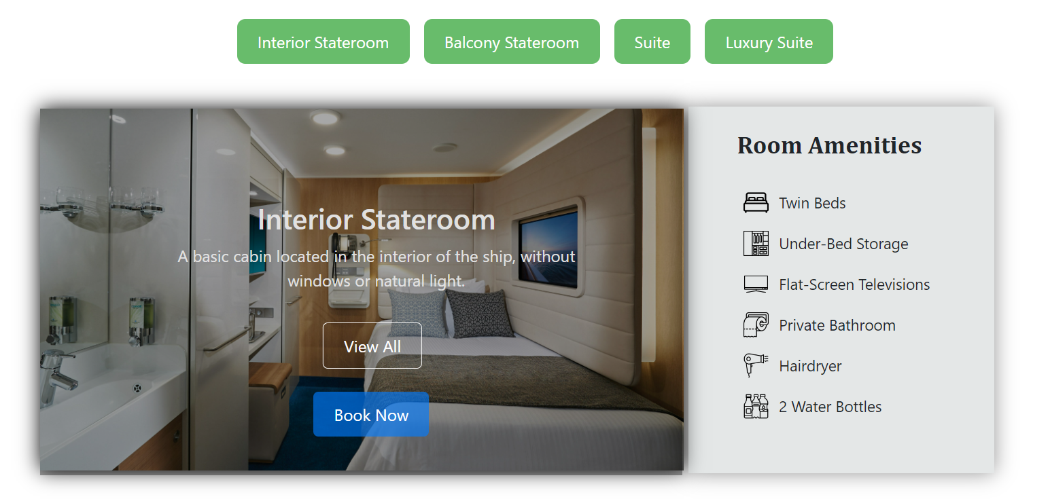

**Fig 5.14 Rooms page**

# Js Code :

import React,{useState} from 'react' import Chart from "react-apexcharts"; import './History.css'

export default function History() { const [state,setState]=useState({ options: {

chart: { id:"basic-bar"

},

xaxis: {

categories: ["Tuesday","Wednesday","Thursday","Friday","Saturday","Sunday"],

},

colors: ["black","black","black","black","black","black"],

},

series: [

26

{

name: "series-1",

data: [2.5,1.7,2.1,3.4,4.0,3.0]

}

]

}

)

return (

<div className="hisfull">

<div className='chart'>

<div className='col-4'>

<Chart options={state.options} series={state.series} type="area" width="900" height={400}

/>

</div>

</div>

</div>

)

}

# ADMIN DASHBOARD

This page shows the dashboard of admin.

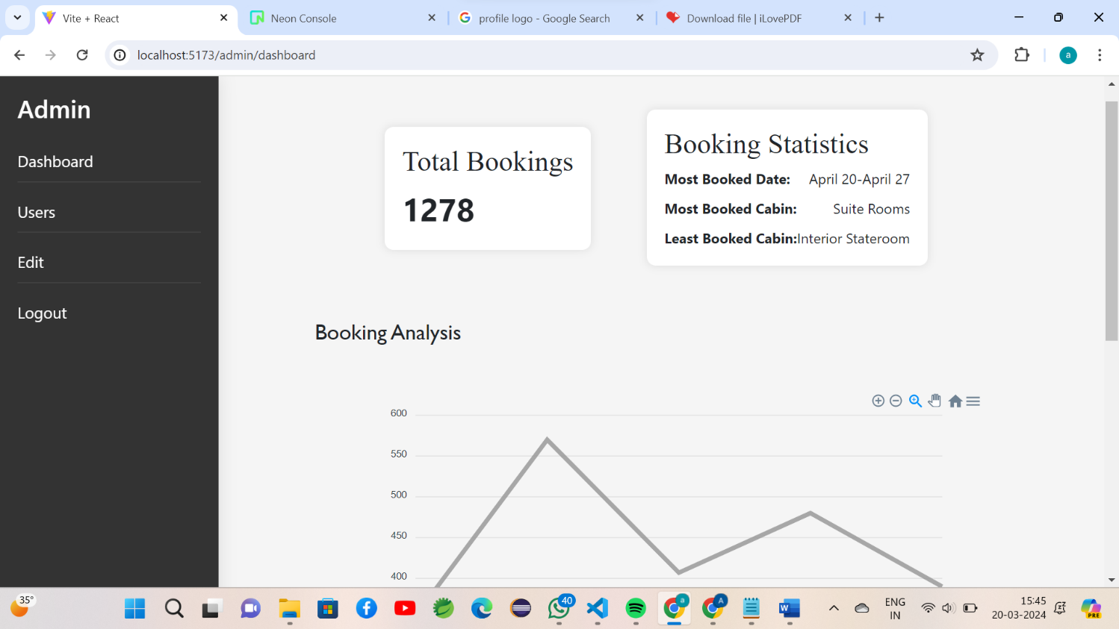27

**Fig 5.15 Admin Dashboard**

# Js Code :

import React ,{useState} from 'react'

import gify from '../Fpage/healthy-water-drinking-water.gif' import './Suggestor.css'

import suggcir from '../Fpage/water_loader.gif'

export default function Suggestor() { const [age, setAge] = useState('');

const [weight, setWeight] = useState('');

const [activityLevel, setActivityLevel] = useState('');

const [climate, setClimate] = useState('');

const [waterIntake, setWaterIntake] = useState(null);

const calculateWaterIntake = (e) => {

e.preventDefault();

const baseIntake = 0.035;

const adjustedIntake = baseIntake * weight;

28

let activityMultiplier = 1.0; if (activityLevel === 'low') { activityMultiplier = 0.5;

} else if (activityLevel === 'moderate') { activityMultiplier = 0.75;

} else if (activityLevel === 'high') { activityMultiplier = 1.0;

}

let climateMultiplier = 1.0; if (climate === 'hot') { climateMultiplier = 1.2;

} else if (climate === 'cold') { climateMultiplier = 0.8;

}

const totalIntake = adjustedIntake * activityMultiplier * climateMultiplier;

setWaterIntake(totalIntake);

};

return (

<div className='suggfull'>

<div className='giffy'><img src={gify} height={500} width={900}></img>

<div className='sugg'>

<h2>Water Intake Calculator</h2>

<form onSubmit={calculateWaterIntake}>

<button type="submit" >Calculate</button> <br />

<br/>

<input type="number" placeholder='Enter your age' value={age} onChange={(e) => setAge(e.target.value)} />

<br />

<input type="number" placeholder='Enter your weight-kg)' value={weight} onChange={(e) => setWeight(e.target.value)} />

<br />

<select value={activityLevel} onChange={(e) => setActivityLevel(e.target.value)}>

<option value="">Select an Activity Level</option>

<option value="low">Low</option>

<option value="moderate">Moderate</option>

<option value="high">High</option>

</select>

<br />

<select value={climate} onChange={(e) => setClimate(e.target.value)}>

<option value="">Select a Climate</option>

<option value="average">Average</option>

<option value="hot">Hot</option>

<option value="cold">Cold</option>

</select>

</form></div>

{waterIntake !== null && (

<div className='recom'>

<h3>daily intake<br></br> level</h3>

<div className='result'>

<p>{waterIntake.toFixed(2)} l</p>

</div>

</div>

)}

</div>

</div>

)

# ADMIN USER

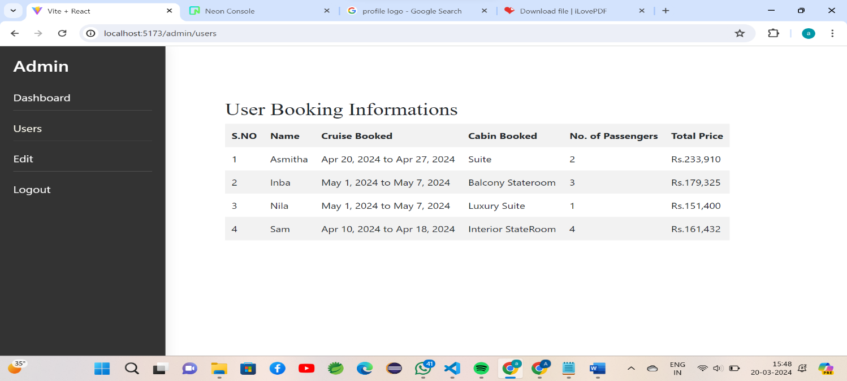This page displays the informations of users along with their booking details.

**Fig 5.16 Admin User Page**

### Js Code :

import React, { useState } from 'react'; import './FeedbackForm.css'

function FeedbackForm() {

const [feedback, setFeedback] = useState(''); const [submitted, setSubmitted] = useState(false);

const handleFeedbackChange = (e) => { setFeedback(e.target.value);

};

const handleSubmit = (e) => { e.preventDefault();

setSubmitted(true);

};

return (

<div className=”feedback-form”>

<h2>Feedback Form</h2>

{submitted ? (

<p>Thank you for your feedback!</p>

) : (

<form onSubmit={handleSubmit}>

<label htmlFor=”feedback”>Please share your feedback:</label>

<textarea id=”feedback” name=”feedback” rows="4" value={feedback}

onChange={handleFeedbackChange} required

></textarea>

<button type="submit">Submit Feedback</button>

</form>

)}

</div>

);

}

export default FeedbackForm;

# ADMIN EDIT PAGE

The FAQ page serves as a comprehensive resource, addressing common questions and providing clear, concise answers to assist users in navigating our platform effortlessly. It's a valuable reference to quickly find solutions and gain insights into various aspects of our services.

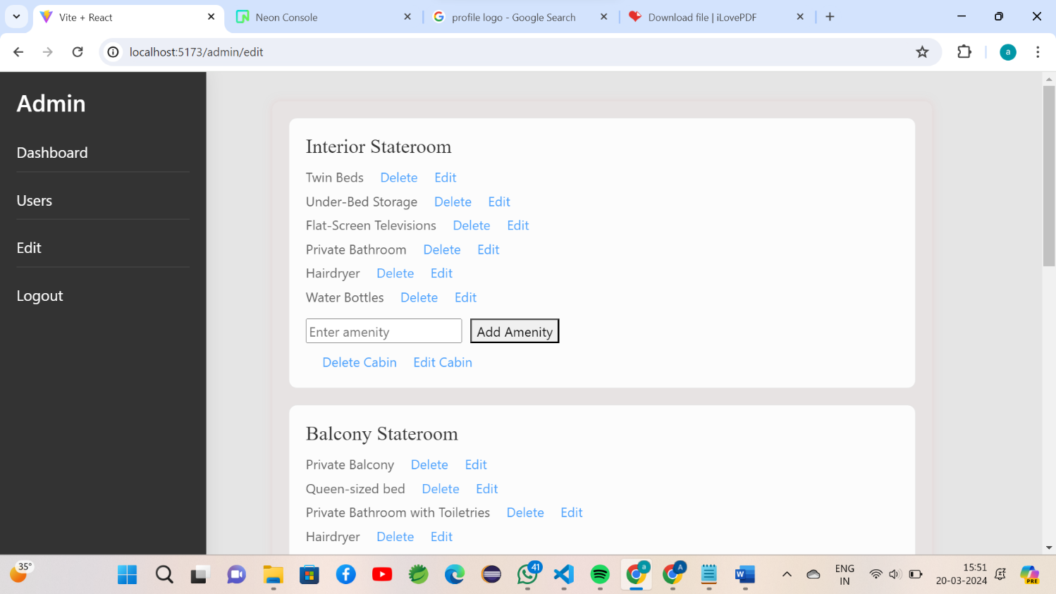

**Fig 5.17 Admin Edit Page**

# Js Code :

import React, { useState } from 'react';

import AdminDashboard from './AdminDashboard'; // Import the AdminDashboard component

import "../assets/css/Edit.css";

const CabinEditing = () => {

const [cabins, setCabins] = useState([

{ id: 1, name: "Interior Stateroom", amenities: ["Twin Beds", "Under-Bed Storage", "Flat-Screen Televisions", "Private Bathroom", "Hairdryer", "Water Bottles"] },

{ id: 2, name: "Balcony Stateroom", amenities: ["Private Balcony", "Queen-sized bed", "Private Bathroom with Toiletries", "Hairdryer", "Daily Housekeeping", "Mini-Refrigerator"] },

{ id: 3, name: "Suite", amenities: ["King-sized bed", "Separate Living Area", "Private Bathroom with Whirlpool Tub", "Private Balcony", "Butler Service", "Concierge Service"] },

{ id: 4, name: "Luxury Suite", amenities: ["Spacious Living Area", "Private Pool", "Personal Chef", "24/7 Butler Service", "Private Helicopter Transfer"] },

]);

const [newCabinName, setNewCabinName] = useState("");

const [newAmenity, setNewAmenity] = useState("");

const [editedAmenity, setEditedAmenity] = useState("");

const [editedCabinName, setEditedCabinName] = useState("");

// Function to add a new cabin

const addCabin = () => {

const newCabin = {

id: Date.now(), // Generate a unique ID

name: newCabinName,

amenities: []

};

setCabins([...cabins, newCabin]);

setNewCabinName("");

};

const deleteCabin = (cabinId) => {

const updatedCabins = cabins.filter(cabin => cabin.id !== cabinId);

setCabins(updatedCabins);

};

const deleteAmenity = (cabinId, amenityIndex) => {

const updatedCabins = cabins.map(cabin => {

if (cabin.id === cabinId)

const updatedAmenities = cabin.amenities.filter((_, index) => index !== amenityIndex);

return { ...cabin, amenities: updatedAmenities };

}

return cabin;

});

setCabins(updatedCabins);

};

const editAmenity = (cabinId, amenityIndex, newAmenity) => {

const updatedCabins = cabins.map(cabin => {

if (cabin.id === cabinId) {

const updatedAmenities = cabin.amenities.map((amenity, index) => {

if (index === amenityIndex) {

return newAmenity;

}

return amenity;

});

return { ...cabin, amenities: updatedAmenities };

}

return cabin;

});

return (

<div>

<div className="grey-layout"></div>

<AdminDashboard />

<div className="cabin-editing-container-custom">

<ul className="amenities-list-custom">

{cabin.amenities.map((amenity, index) => (

<li key={index}>

{amenity}

<span className="link" onClick={() => deleteAmenity(cabin.id, index)}>Delete</span>

<span className="link" onClick={() => {

const editedValue = prompt("Enter edited amenity:");

if (editedValue !== null) {

editAmenity(cabin.id, index, editedValue);

}

}}>Edit</span>

</li>

))}

<button className="add-cabin-button-custom" type="submit">Add Cabin</button>

</form>

</div>

</div>

);

};

export default CabinEditing;

**CONCLUSION**

42

# CHAPTER 6 CONCLUSION

In conclusion, Aqua Cruise Booker stands as a testament to innovation and advancement in the realm of cruise vacation booking. Through its user-centric design, cutting-edge technology, and unwavering commitment to customer satisfaction, Aqua Cruise Booker has redefined the way travelers plan and experience their dream voyages at sea.

By simplifying the booking process and providing transparent, real-time information, Aqua Cruise Booker empowers travelers to make informed decisions with confidence. Its personalized recommendations and tailored experiences cater to the unique preferences of each individual, ensuring that every cruise vacation is a reflection of their desires and interests.

# FUTURE SCOPE

Aqua Cruise Booker has the potential to expand its partnerships with a wider array of cruise lines. This expansion would not only offer travelers a broader selection of cruise options but also cater to various preferences and budgets. Niche cruise experiences, themed cruises, and new destinations could be included to enrich the choices available to travelers.

# REFERENCES

43

### REFERENCES

1. All Basics [www.javatpoint.com](http://www.javatpoint.com/)
2. The basic diagram of the HTML/HTML5 5/24/201844 <http://www.modelrumahminimalis.co/html-> menutemplatesfreedownload/69033.html/top-result-html-menu-templates- freedownloadinspirationalgenerous-menu-template-html-images-entry- levelresumetemplates-picture-2017-hdj5
3. [www.w3schools.com](http://www.w3schools.com/)
4. Fielding, R. T. (2000). Architectural Styles and the Design of Network-based Software Architectures.
5. React Documentation: https://reactjs.org/docs/getting-started.html
6. React Tutorial (MDN Web Docs): https://developer.mozilla.org/enUS/Learn/Tools_and_testing/client